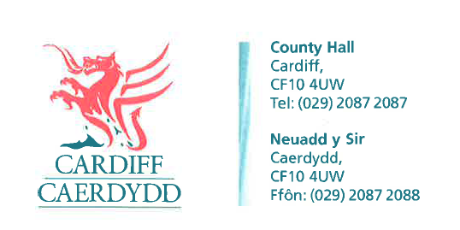
FOI11174
Thank you for your request under the Freedom of Information Act 2000 about Framework/Contract Supplier Tenders received on 05/01/2018.
Request:
- Suppliers who applied for inclusion on each framework/contract attached and were successful & not successful at the PQQ & ITT stages.

- Contract values of each framework/contract (& any sub lots), year to date

- Start date & duration of framework

- Is there an extension clause in the framework(s)/contract(s) and, if so, the duration of the extension?

- Has a decision been made yet on whether the framework(s)/contract(s) are being either extended or renewed?
We have considered your request and enclose the following information:
- The Council initially procured this through the Crown Commercial Service Framework – PS2014ES
Successful – Psychonnaissance
Unsuccessful – Miles and Equal approach Ltd

- Contract Value – £25,000
Extended Contract Value - £50,000

- Start Date - 20/04/2015
Duration - 3 Months

- Contract Extension – Yes
Duration - 7 Months

- An extension was taken up taken up at the time. There has been no decisions made going forward.
If you have any queries or concerns, please do not hesitate to contact us.
Please remember to quote the reference number above in any future communications.

